1. First, download wildfly 23.0.2.Final

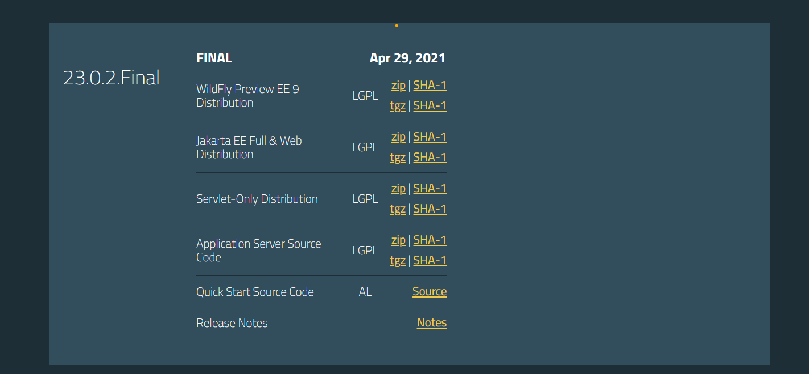

Download the Jakarta ee full and web distribution

1. This will take a long time. After downloading, extract it. This will take an even longer time
2. After extraction, go to the bin folder of the new folder and open git bash in it
3. Then add 2 users using the following script in git bash

$ ./add-user.sh -a -u kieserver -p kieserver1! -g kie-server

$ ./add-user.sh -a -u krisv -p krisv -g admin,kie-server,rest-all

1. Use git bash for the above user adding
2. Now, will need to download the following
3. Business-central-7.62.0.Final-wildfly23.war
4. Kie-server-distribution-7.62.0.Final.zip

Rename kie-server-7.62.0.Final-ee7.war to kie-server.war

Business central war rename it to business-central.war

Then add

Kie-server.war, business-central.war, kie-server-router-proxy and kie server controller standalone to the standalone/deployments folder of the wildfly folder

1. Now go to the standalone/configuration folder of the wildfly and open standalone-full. Xml and add the following jus below the </extensions>
2. <**system-properties**>
3. <**property** **name=**"org.kie.server.id" **value=**"sample-server"/>
4. <**property** **name=**"org.kie.server.controller" **value=**"http://localhost:8080/business-central/rest/controller"/>
5. <**property** **name=**"org.kie.server.location" **value=**"http://localhost:8080/kie-server/services/rest/server"/>
6. <**property** **name=**"org.kie.server.user" **value=**"krisv"/>
7. <**property** **name=**"org.kie.server.pwd" **value=**"krisv"/>
8. <**property** **name=**"org.kie.server.controller.user" **value=**"krisv"/>
9. <**property** **name=**"org.kie.server.controller.pwd" **value=**"krisv"/>
10. </**system-properties**>
11. Now, go to the standalone.conf file and amend the following line to this
12. JBOSS_JAVA_SIZING="-Xms128m -Xmx4096m -XX:MetaspaceSize=512M -XX:MaxMetaspaceSize=1024m"
13. Now, open the bin folder of the wildfly in git and run the following command
14. ./standalone.sh -c standalone-full.xml
15. This will start up biz central
16. Once biz central is up
17. Go to localhost:8080/business-central/kie-wb.jsp and click on the “deploy” tab, there should be a remote server there
18. Now ready to go to the next step
19. Now, the next step is to create a project in business central and deploy it to the kie server
20. Go to design tab of business central and “add space”
21. Create a space ASB_Space
22. In that space add a project
23. Graphical user interface, application

    Description automatically generated
24. Now in the projects, will need to add assets
25. Add a data object asset- call it IncomeDetails and put it in package com.asb.example
26. Add 2 fields
27. incomeInRupees of type int
28. incomeTaxPercentage of type double
29. save
30. go back and add another asset
31. this time add a .DRL file and call it IncomeTaxCalculator
32. add the following in the file

**package** com.asb.example;

**import** com.asb.example.IncomeDetails;

rule "Rs 0.0 – Rs 2.5 Lakhs"

when

incomeDetails: IncomeDetails**(**incomeInRupees **>** 0 && incomeInRupees **<** 250000**)**

then

incomeDetails.setIncomeTaxPercentage**(**0.0**)**;

end

rule "Rs 2.5 lakhs - Rs 5.0 Lakhs"

when

incomeDetails: IncomeDetails**(**incomeInRupees **>** 250000 && incomeInRupees **<** 500000**)**

then

incomeDetails.setIncomeTaxPercentage**(**5.0**)**;

end

rule "Rs. 5.00 lakhs- Rs 7.5 Lakhs"

when

incomeDetails: IncomeDetails**(**incomeInRupees **>** 500000 && incomeInRupees **<** 750000**)**

then

incomeDetails.setIncomeTaxPercentage**(**10.0**)**;

end

rule "Rs 7.5 lakhs – Rs 10.00 Lakhs"

when

incomeDetails: IncomeDetails**(**incomeInRupees **>** 750000 && incomeInRupees **<** 1000000**)**

then

incomeDetails.setIncomeTaxPercentage**(**15.0**)**;

end

rule "Rs 10.00 lakhs – Rs. 12.50 Lakhs"

when

incomeDetails: IncomeDetails**(**incomeInRupees **>** 1000000 && incomeInRupees **<** 1250000**)**

then

incomeDetails.setIncomeTaxPercentage**(**20.0**)**;

end

rule "Rs. 12.5 lakhs- Rs. 15.00 Lakhs"

when

incomeDetails: IncomeDetails**(**incomeInRupees **>** 1250000 && incomeInRupees **<** 1500000**)**

then

incomeDetails.setIncomeTaxPercentage**(**25.0**)**;

end

rule "> Rs. 15 Lakhs"

when

incomeDetails: IncomeDetails**(**incomeInRupees **>** 1500000**)**

then

incomeDetails.setIncomeTaxPercentage**(**30.0**)**;

end

1. after adding need to build and deploy – this will deploy the above project into the kie server so that it can be called from a java application
2. A screenshot of a computer

   Description automatically generated
3. Now can hit from the java project already
4. The project is in the github repo